UNF : A table that contains one or more repeating groups. In this part our goal is to simplify our columns and rows.Our Unf and 1nf almost same because theres no repeating groups. To pass the 1NF , we must identify our Primary Key .We choose Project ID for primary key and we create another table name as Project.

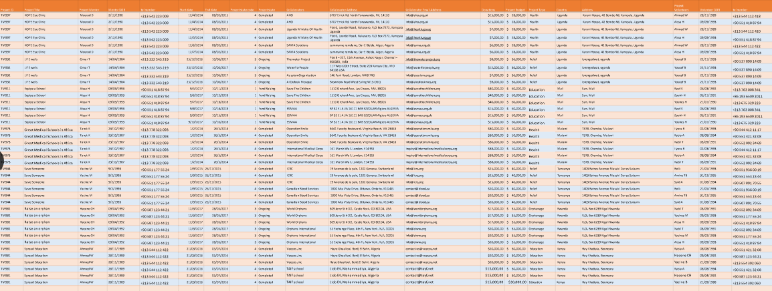

1NF : Our Primary Key is Project ID. In 1NF,we remove the repeating groups . We create a different table name as Project.We remove same groups and we write them in one row. In Project table we have(Project Title , Project Mentor , Mentor DOB , tel number , Start date , End date , Project state code , Project state , Project Budget , Project Type , Country , Address). For instance ; we have 6 columns (HOPE eye clinic ) as a Project Title .We decrease that column value. It’s help us which mean 1NF help us in data about to work easy . After we remove same values in columns we just interest with 1 column . Its easy to arrive values and we dont fill data with same values.It gives more area to work in data .

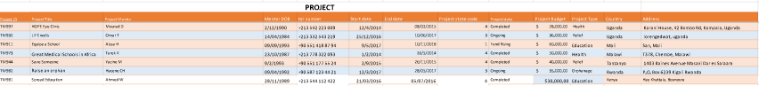

On the other hand , we have still first table standing. All values out of Project table in our first table. We have ProjectID for the connection . We have ( Collobrators , Collobrator Address , Donations , Project Volunteers , Volunteer DOB , telNumber).

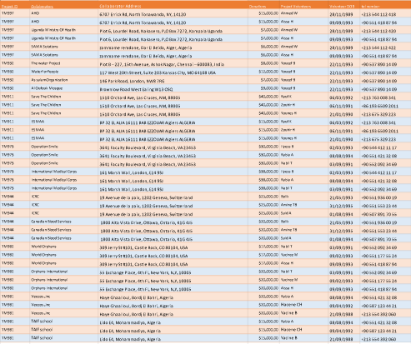

In first table has values we couldnt seperate with Primary Key. This columns can diversity their rows.To pass the 2NF we also need to seperate our first table with new PrimaryKeys and Foreign Keys .

2NF : We can just create over 1NF. No subsetof data should be repeated on multiple lines. New tables should be created for such data sub-sets. Relationships between the main table and the new tables must be defined using foreign keys. We must define the relationship between the tables we obtain and the main table.We choose 2 more column to seperate detaily.We take in 4 hand our data.

PROJECT : It’s different than first Project table . We seperate (ProjectMentor , Mentor DOB, Mentor telNumber). We create another table name as Mentor and Project Mentor is also in our first Project table to communicate with our first table . If even we sperate this columns and values we still have to arrive that values and we going to arrive them with Project Mentor.

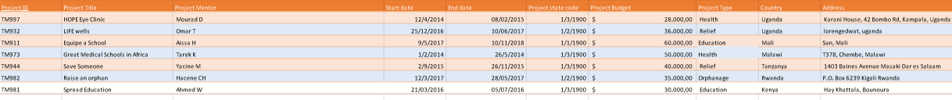

MENTOR : We took this columns to new table cause they’re relationship with each other and we need to create new tables with sub-sets.It’s easy to define values and easy to arrives.Our new table connect Project table with Project Mentor and it connect our first data base.

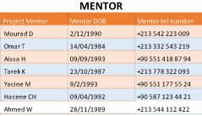

COLLABORATOR :

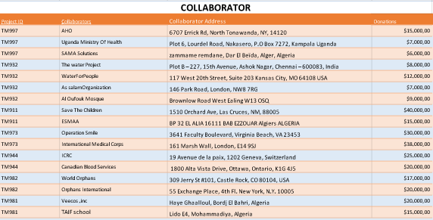

In this part we seperate collobrators and volunteers in some point. Our 1NF we did seperate 2 tables our first data. Project and firstc data. In our first table we couldn’t seperate more cause it was diversity it’s inside.In 2NF we choose foreign keys as Collaborators and Volunteers.We first create a table name as Collaborator and we took same column values with them.We must put our Primary Key in first column cause , in Mentor was inside the Project table. But either Collaborator or Volunteers has no value inside of Project table .We put our Primary Key cause we need to arrive inside of Collaborator and Volunteer to take columns and values.

VOLUNTEER : The Volunteer part also same content with collaborator.We write ProjectId to reach values inside table. Our Foreign Key is Project Volunteers

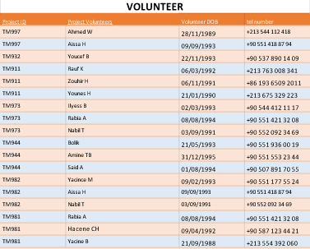

#We gave numbers for each term of

Project state . to use more with ease.

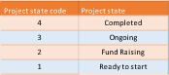

We took in 4 hand our 1NF while convert 2NF . We decide our Foreıgn Keys as (ProjectMentor , Collaborator , Project Volunteer). To convert 3NF Each column has to be fully dependent on the unique Primary Key.

3NF : Every Primary Key can be Foreign Key but every Foreign Key can NOT be Primary Key .

First lets introduce our Primary and Foreign Keys.

Primary Keys : (Project ID – Project Volunteer - Collaborator )